1. Hasil screenshot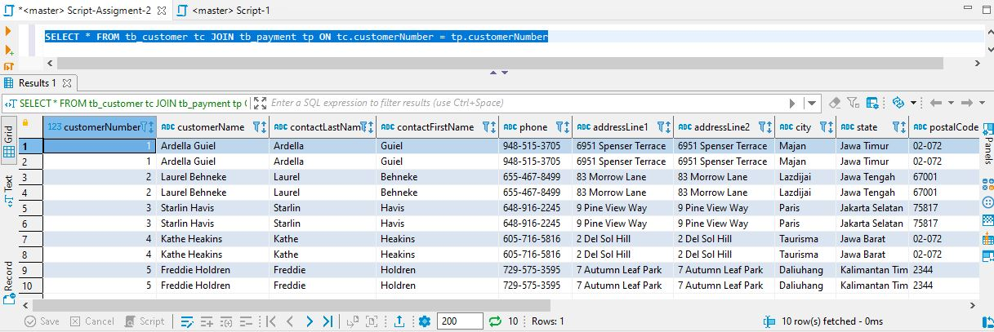

No. 1 Soal: Tabel customer join dengan table payment

Jawaban Query Soal No. 1

SELECT * FROM tb_customer tc JOIN tb_payment tp ON tc.customerNumber = tp.customerNumber

1. Hasil screenshot

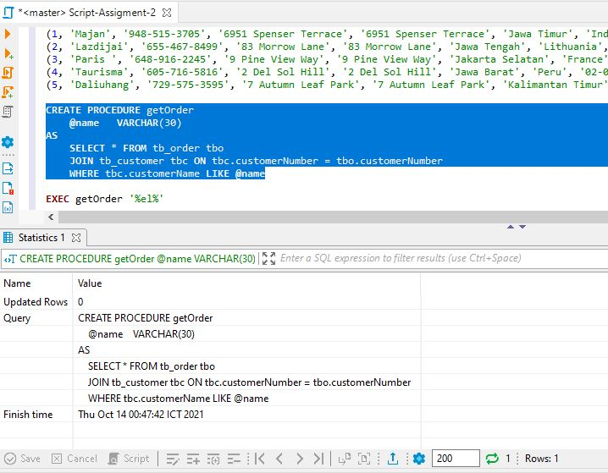

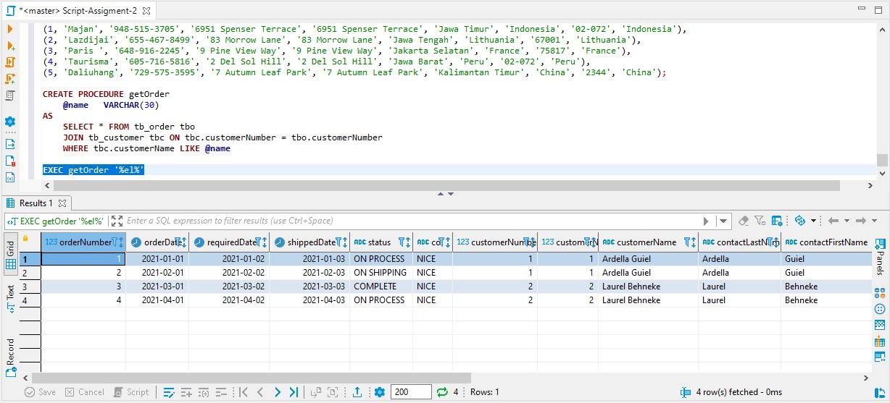No. 2 Soal: Membuat prosedur mendapatkan data order dari customer berdasarkan inputan nama customer

Jawaban Query Soal No. 2

CREATE PROCEDURE getOrder

@name VARCHAR(30)

AS

SELECT * FROM tb_order tbo

JOIN tb_customer tbc ON tbc.customerNumber =

tbo.customerNumber

WHERE tbc.customerName LIKE @name

EXEC getOrder '%el%'

1. Hasil screenshot

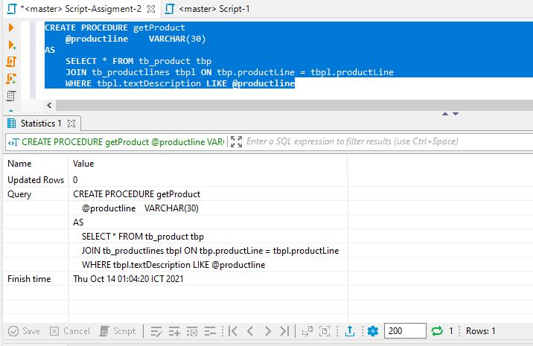

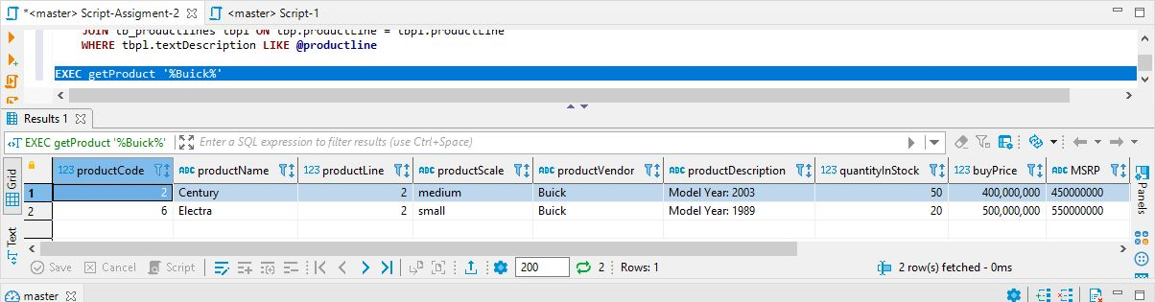

NO.3 Soal: Membuat prosedur mendapatkan data product berdasarkan inputan text deskripsi productlines

Jawaban Query Soal No. 3

CREATE PROCEDURE getProduct

@productline VARCHAR(30)

AS

SELECT * FROM tb_product tbp

JOIN tb_productlines tbpl ON tbp.productLine =

tbpl.productLine

WHERE tbpl.textDescription LIKE @productline

EXEC getProduct '%Buick%'